Bank Loan SQL Queries

KPI’s

Total Loan Applications:
Select Count(ID) as Total_Loan_Applications
From Bank_Loan

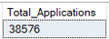

MTD Loan Applications:
Select Count(ID) as PMTD_Total_Loan_Applications
From Bank_Loan
Where month(issue_date) = 12 AND Year(issue_date) = 2021

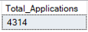

PMTD Loan Applications:
Select Count(ID) as PMTD_Total_Loan_Applications
From Bank_Loan
Where month(issue_date) = 11 AND Year(issue_date) = 2021

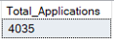

Total Funded Amount:
Select Sum(Loan_amount) as Total_funded_Amount
From BankLoanDB..Bank_Loan

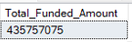

Total Funded Amount MTM:
Select Sum(Loan_amount) as MTD_Total_funded_Amount
From BankLoanDB..Bank_Loan
Where Month(issue_date) = 12 and Year(issue_date) = 2021

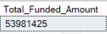

Total Funded Amount PMTM:
Select Sum(Loan_amount) as PMTD_Total_funded_Amount
From BankLoanDB..Bank_Loan
Where Month(issue_date) = 11 and Year(issue_date) = 2021

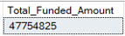

Total Amount Received:
Select Sum(total_payment) as Total_Amount_Recieved
From BankLoanDB..Bank_Loan

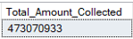

Total Amount Received MTM:
Select Sum(total_payment) as MTM_Total_Amount_Recieved
From BankLoanDB..Bank_Loan
Where Month(issue_date) = 12 and Year(issue_date) = 2021

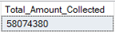

Total Amount Received PMTD:
Select Sum(total_payment) as PMTD_Total_Amount_Recieved
From BankLoanDB..Bank_Loan
Where Month(issue_date) = 11 and Year(issue_date) = 2021

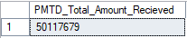

Average Interest Rate:
Select ROUND(AVG(CAST(int_rate AS float)), 4) * 100 as AVG_Interest_Rate
From BankLoanDB..Bank_Loan

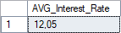

Average Interest Rate MTD:
Select ROUND(AVG(CAST(int_rate AS float)), 4) * 100 as MTD_AVG_Interest_Rate
From BankLoanDB..Bank_Loan
Where Month(issue_date) = 12 AND Year(issue_date)=2021

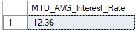

Average Interest Amount PMTD
Select ROUND(AVG(CAST(int_rate AS float)), 4) * 100 as PMTD_AVG_Interest_Rate
From BankLoanDB..Bank_Loan
Where Month(issue_date) = 11 AND Year(issue_date)=2021

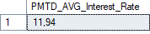

Average Debt to Income Ratio:
Select Round(AVG(CAST(dti as Float)), 4) * 100 as AVG_DTI
From BankLoanDB..Bank_Loan

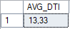

Average Debt to Income Ratio MTD:
Select Round(AVG(CAST(dti as Float)), 4) * 100 as MTD_AVG_DTI
From BankLoanDB..Bank_Loan
Where Month(issue_date) = 12 AND Year(issue_date)= 2021

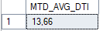

Average Debt to Income Ratio PMTD:
Select Round(AVG(CAST(dti as Float)), 4) * 100 as PMTD_AVG_DTI
From BankLoanDB..Bank_Loan
Where Month(issue_date) = 11 AND Year(issue_date)= 2021

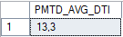

Good VS Bad Loan KPI

Good Loan Percentage:
Select
Count(CASE WHEN loan_status = 'Fully Paid' OR loan_status = 'Current' THEN id END) *100
/
COUNT(id) AS Good_Loan_percentage
From BankLoanDB..Bank_Loan

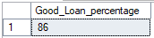

Good Loan Applications:
Select Count(id) Good_Loan_Applications
From BankLoanDB..Bank_Loan
Where loan_status = 'Fully Paid' or loan_status = 'Current'

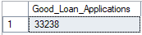

Good Loan Funded Amount
Select SUM(loan_amount) AS Good_Loan_funded_Amount
From BankLoanDB..Bank_Loan
WHERE loan_status = 'Fully Paid' or loan_status = 'Current'

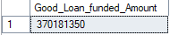

Good Loan Total Received Amount:
Select SUM(total_payment) AS Good_Loan_Recieved_Amount
From BankLoanDB..Bank_Loan
WHERE loan_status = 'Fully Paid' or loan_status = 'Current'

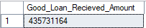

Bad Loan Percentage
Select Count(CASE WHEN loan_status = 'Charged Off' Then id END) * 100
/
Count(id) AS Bad_loan_Percentage
From BankLoanDB..Bank_Loan

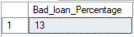

Bad Loan Applications:
Select COUNT(id) AS Bad_Loan_Applications
From BankLoanDB..Bank_Loan
Where loan_status = 'Charged Off'

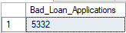

Bad loan Funded
Select SUM(loan_amount) as Bad_loan_Funded_Amount
From BankLoanDB..Bank_Loan
Where loan_status = 'Charged Off'

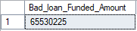

Bad Loan Amount Received
Select SUM(total_payment) AS Bad_Loan_Amount_Recieved
From BankLoanDB..Bank_Loan
Where loan_status = 'Charged Off'

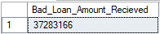

Loan Status Grade View
Select
loan_status,
Count(id) AS Total_Loan_Applications,
SUM(total_payment) as Total_Amount_Recieved,
SUM(loan_amount) as Total_Funded_Amount,
Round(AVG(CAST(int_rate as float) * 100),2) as Interest_Rate,
Round(AVG(Cast(dti as float) * 100),2) as DTI
From BankLoanDB..Bank_Loan
Group By loan_status

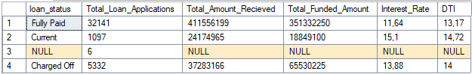

Loan Status Grade View MTD
Select
loan_status,
SUM(total_payment) as MTD_Total_Amount_Recieved,
SUM(loan_amount) as MTD_Total_Funded_Amount
From BankLoanDB..Bank_Loan
Where MONTH(issue_date) = 12
Group By loan_status

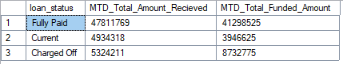

Monthly Trends By Issue Date
Select
Month(issue_date) as Month_Number,
DATENAME(MONTH,issue_date) as Month_Name,
Count(id) AS Total_loan_Applications,
Sum(loan_amount) as Total_Funded_Amount,
Sum(total_payment) as Total_Recieved_Amount
From BankLoanDB..Bank_Loan
Group By Month(issue_date),DATENAME(MONTH,issue_date)
Order By Month(issue_date)

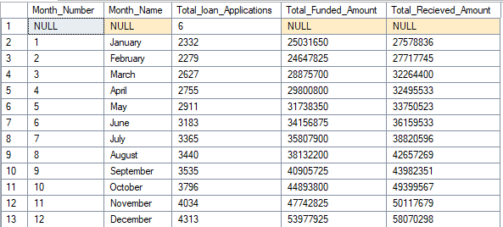

Regional Analysis By State
Select
address_state,
Count(id) AS Total_Loan_Applications,
SUM(loan_amount) AS Total_Funeded_Amount,
SUM(total_payment) AS Total_REcieved_Amount
From BankLoanDB..Bank_Loan
Group By address_state
Order BY SUM(loan_amount) desc

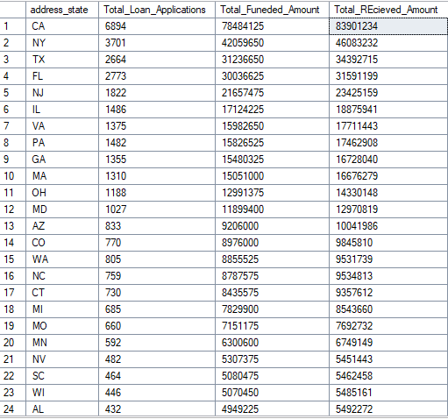
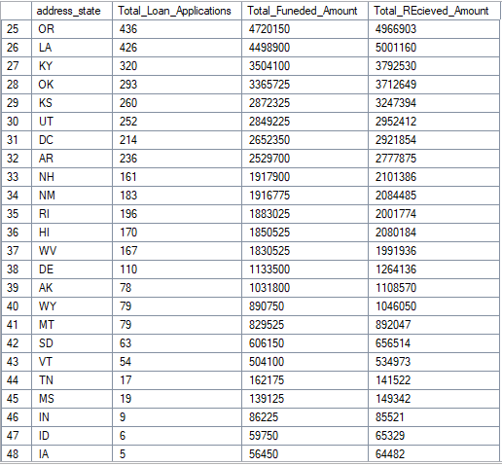

Loan Term Analysis
Select
term,
Count(id) AS Total_Loan_Applications,
SUM(loan_amount) AS Total_Funeded_Amount,
SUM(total_payment) AS Total_REcieved_Amount
From BankLoanDB..Bank_Loan
Group By term
Order By term

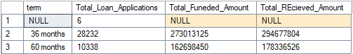

Employee Length Analysis
Select
emp_length,
Count(id) AS Total_Loan_Applications,
SUM(loan_amount) AS Total_Funeded_Amount,
SUM(total_payment) AS Total_REcieved_Amount
From BankLoanDB..Bank_Loan
Group By emp_length
Order By emp_length

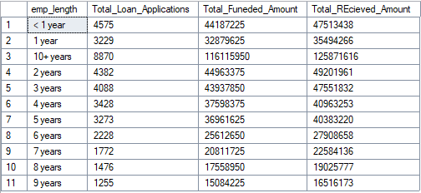

Loan Purpose Breakdown:
Select
purpose,
Count(id) AS Total_Loan_Applications,
SUM(loan_amount) AS Total_Funeded_Amount,
SUM(total_payment) AS Total_REcieved_Amount
From BankLoanDB..Bank_Loan
Group By purpose
Order By purpose desc

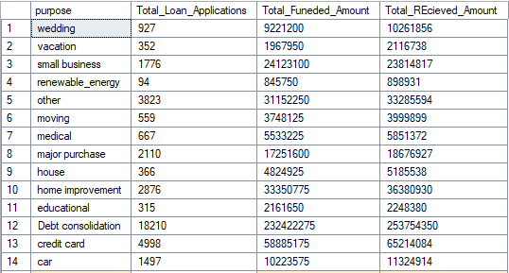

Home Ownership Analysis
Select
home_ownership,
Count(id) AS Total_Loan_Applications,
SUM(loan_amount) AS Total_Funeded_Amount,
SUM(total_payment) AS Total_REcieved_Amount
From BankLoanDB..Bank_Loan
Group By home_ownership
Order By Count(id) desc

